 | Chapter 3 General Accounting
 | The General Ledger contains many important processes that ensure the KFS runs correctly. For users processing e-doc transactions, the most apparent of these functions are the generation of offsets and the posting of transactions to the balance tables. However, there are several other important General Ledger processes that ensure transaction data is valid, capitalization entries are created, and indirect cost recovery and cost share transfers occur. The KFS also offers features such as Sufficient Funds checking and Flexible Offsets, for institutions that wish to utilize this functionality.
Topics |  | General Ledger Process 3-2  Sufficient Funds 3-11  Flexible Offset 3-14  General Ledger Correction Process (GLCP) 3-17

General Ledger Process
The General Ledger is the official repository for all of the University’s financial and budget information. It stores account balance and budget information for multiple fiscal years as well as a detailed record of all financial transactions. Unlike other parts of the KFS, users do not directly interact with the General Ledger. Instead, users who wish to modify financial information in the General Ledger do so by creating e-docs that, when fully approved, are posted to the General Ledger.
The KFS has several behind-the-scenes processes that maintain the information in the General Ledger. This section discusses those processes. Because there is no direct user interaction with these processes, the information in this section is primarily informational. This section also assumes that General Ledger processing takes place in a batch, meaning that the processes run at a given time for all pending transactions with the General Ledger being updated after the processes have completed.
The processes discussed include:
- Scrubber
- De-Merge
- Poster

Scrubber
The scrubber receives accounting transactions from e-docs entered into KFS and from external systems such as enterprise level systems (such as Payroll, Travel, Student systems) or other systems external to the KFS.
The scrubber performs the following primary functions which are discussed in more detail in the section below:

- Validation of Data: Including the addition of some missing values, validation against the Chart of Accounts and the application of continuation account logic.
- Offset and Entry Generation: Including document balancing, capitalization of assets and liabilities, plant indebtedness, cost share transfers and cost share encumbrances.
- Error Handling: Identification of errors to be corrected using the General Ledger Correction Process document.

Validation of Data
Data must be validated before being posted to the General Ledger to ensure that it is complete and correct. Before ledger entries are posted to the General Ledger, a transaction validation process is run to ensure that bad data, such as transactions applied to non-existent Object Codes or accounts, does not get posted to the ledger.
Financial transaction e-docs generate Pending Ledger Entries automatically. The KFS validates transactions created via e-docs in various ways, using the Chart of Accounts and Business Rules to ensure that the entries generated are complete and without errors.

Transactions from External Systems
Transactions that are fed into the KFS from an outside system (such as a payroll or external billing system) are more likely to have invalid data as they may not be integrated with the KFS Chart of Accounts. Therefore, it is more likely for these systems to send the KFS data in need of correction. For example, an external system might try to apply expenses to a closed account because that external system does not have access to the data in the KFS Chart of Accounts.

Transaction Validation Process
All transactions are validated by the Transaction Validation process. Because some systems may not be capable of providing all of the information required to post a general ledger transaction, the Scrubber may assign some attributes to complete the transaction.
If necessary, the Scrubber can assign a Fiscal Year, Fiscal Period and Transaction Date to the transaction based on the system date, determined by when the batch process is run. It can also assign an Object Code Type based on the Object Code of the transaction.
The process checks to make sure that accounting string values are valid (such as Account, Object Code and Sub-Object Code). It also ensures that the transaction has proper identifying information attached to it, such as a Document Number, Document Type and Origination Code, indicating what system it came from.

Continuation Account for Expired Account
Special logic is also applied in the Scrubber to determine if a continuation account should be substituted for the account on a transaction. This logic is triggered when the account on the transaction has an expiration date or is closed. If the account specified is closed and the transaction comes from the KFS system or other originating systems as defined by the institution, the transaction is removed and flagged as an error.
Just because an account is identified as expired does not mean that the Scrubber uses that account’s continuation account. When configuring the KFS, institutions can choose to exclude transactions with certain Origination Codes, Balance Types and Document Types from application of the continuation account logic. For example, in most instances we would want to exclude transactions generated by KFS e-docs from this process. Financial e-docs include a process that verifies that a document initiator wants to use an expired account and gives them the option to instead select that account’s continuation account.

If a transaction applies to an expired account and is not otherwise excluded, the Scrubber attempts to find a valid continuation account to substitute. Accounts are considered expired if their expiration date is less than or equal to the run date of the Scrubber batch process. Three months are added to the expiration date of Contract and Grant accounts for the purposes of determining expiration for this process.
The KFS makes ten attempts at finding a valid continuation account before reporting an error. ‘Valid’ in this instance means that the account exists in the account table and is not expired or closed. If a substitution is made the KFS adds AUTO FR and the original account number into the transaction description for tracking purposes.

General Ledger Error Correction Process
If an error is encountered during any part of the validation process, the associated document(s) are not posted. These documents are passed to a General Ledger Error Correction Process, discussed later in this section. This process allows for the manual correction of these errors so these documents may be re-posted in a future batch cycle.

Offset Generation
The Scrubber also ensures that all transactions are balanced and it generates required offsets with an Offset Generation process.
For transactions created via KFS e-docs, offsets should already be in place. The KFS ensures that these transactions are balanced by automatically generating any required offsets when the document is submitted for approval. Prior to the batch process running, the offset transaction lines (such as offsets to cash) may be viewed within the General Ledger Pending Entry section of a Financial Transaction document.
Transactions created in other systems may need to have offsets generated to ensure a balanced transaction. The KFS uses the Offset Definition table to define how offsets should be generated for unbalanced transactions. This table uses information from the unbalanced transaction (such as the Fiscal Year and Chart the transaction is being posted to and the Balance Type and Document Type associated with the transaction) to determine what Object Code should be assigned to offset entries. Ledger Entries created with a Journal Voucher Document Type are specifically excluded from the Offset Generation process. As part of the system implementation process, users must verify that all external system feeds into the KFS are appropriately addressed in the Offset Definition table.

Generated Transactions
In addition to the basic balancing offsets, there are additional processes in the scrubber that can be turned on or off by an institution. The following processes generate behind the scenes transactions and are discussed in detail below:
- Capitalization of Moveable and Non-Moveable Assets and of Liabilities for Lease Purchases
- Plant Indebtedness Related to Bonds
- Cost Share Transfers
- Cost Share Encumbrances

Capitalization of Assets and Liabilities
The Scrubber process generates entries and offsets to properly record the capitalization of assets and liabilities. The KFS determines which items need capitalization entries by looking for transactions affecting the ‘Actuals’ Balance Type and using an Object Code with an asset-related Object Sub-Type.
If it is determined that a qualifying capital expenditure has occurred, then capitalization entries are generated to book an asset to the appropriate plant fund account under the appropriate plant fund Object Code. This is generally the plant fund account associated with the Organization owning the account on which the original transaction occurred (for movable assets), or the plant fund account associated with that Organization’s campus (for non-movable assets).
The KFS includes ‘Generated Capitalization’ or ‘Generated Liability’ in the transaction description of the generated entry and also sets the Object Code Type to ‘Asset’ or ‘Liability’ as appropriate. The Object Sub-Type of the expenditure determines the Object Code used on the generated entry.

Transactions created on Journal Vouchers, Transfer of Funds, Auxiliary Voucher (Accrual Type) or one of the four Year-End document types are excluded from the Capitalization process. Transactions associated with particular Sub-Fund Groups or Charts may also be institutionally excluded from the Capitalization process.

Plant Indebtedness
Plant indebtedness entries for notes and bonds payable are similar in nature to the capitalization entries, with a few exceptions. The original plant indebtedness entries occur on liability Object Codes (a balance sheet item) and, because there are fewer classifications, the same Object Code is used to record the item in the plant fund. Whereas the capitalization entries add items to the balance sheet (set up assets), these entries move the liability from select fund groups to the plant fund.
To generate the bond and note liability in the plant fund, a transaction must have a Balance Type of 'Actuals,' and belong to an institutionally-specified Sub-Fund Group and Object Code Sub-Type. The process then uses the organization associated with the account of the original transaction to determine the correct plant fund account number. The campus plant fund account is always used for plant indebtedness entries.
The KFS includes ‘Transfer to Net Plant’ in the transaction description of the entry occurring in the original account and sets the description of the entry occurring on the Plant Fund account to ‘Generated Transfer from (chart and account number of original entry)’. In addition, appropriate offsets to the Fund Balance Object Code, to balance the entries, are also generated.

Cost Share Transfers
Cost Sharing allows for sharing of costs related to Contract and Grant accounts. Expenses associated with a Grant or Contract that are not paid by the sponsoring agency are considered to be Cost Share and the KFS can track these expenses in special Cost Share Sub-Accounts. A Cost Share Sub-Account is created as part of the Contract or Grant account for which costs are being shared. The Sub-Account is also assigned a ‘source account’ which indicates what account actually bears the expenses that are being shared.
Cost share transfers involve transferring funds into a Contract and Grant Cost Share Sub-Account (to record income), from the source account (to record the charge). Any Expense, except those on a JV or Auxiliary Voucher (Accrual Type) that occurs on a Cost Share Sub-Account is eligible for this transfer of funds. In order to qualify for cost share transfers the transaction must be associated with an expense Object Code Type, have a Balance Type of ‘Actuals,’ and be on a Contract and Grant Account and a Sub-Account with a Sub-Account type of CS. Cost Share Transfers are posted at a summary level. For the income side of the transfer the Document Type is TF (Transfer of Funds) and the Object Code is an institutionally-defined Transfer of Funds revenues code. The Origin Code of the transaction is set to CS (Cost Share), the document number is pre-fixed with CSHR, the transaction description is set to ‘Generated Cost Share from account XXXXXXX MM/DD’ and the transaction date is set to the run date of the process. An appropriate offset to cash for the income side of the transfer is also generated.
For the expense side of the transfer, much of the above logic applies with a few changes. The Chart, Account, and Sub-Account for the source account that was found on the sub-account table are used. The transaction description is set to ‘Generated Cost Share from account XXXXXXX MM/DD’. The correct Object Code to use for the charge is determined by the Object Code Level. A KFS parameter maps Object Code Levels to specific institution-defined Object Codes to which the Cost Share transfers are recorded.

Cost Share Encumbrances
Cost share encumbrances are a management tool that enables the Fiscal Officer of a source account to forecast the cost share transfer activity that occurs once expenses are realized on the Contract and Grant Cost Share Sub-Account. Any encumbrances on a Cost Share Sub-Account trigger the generation of cost share encumbrances in the source account.
The KFS looks at the encumbrances associated with a Cost Share Sub-Account and generates matching encumbrances on the source account to reflect where these expenses are ultimately applied. Eligible transactions must have an expense Object Type, an Encumbrance Balance Type and be on a Contract and Grant Account and a Sub-Account with a Sub-Account type of CS.

These encumbrances are created with a Cost Share Encumbrance Balance Type to ensure that they can be distinguished from the original encumbrances. Cost share encumbrances are posted at the detail level, using the same Object Code Level mapping that was used for cost share transfers. Transactions with a Document Type of Journal Voucher or Auxiliary Voucher (Accrual Type) are excluded from the Cost Share Encumbrance process.

De-Merge
The De-Merge process is initiated after the Scrubber and prior to the main poster. The De-Merge process has several functions.
Using the errors identified by the Scrubber, it locates all of the accounting entries for each document number with a reported error.
It removes any offsets that were generated by the Scrubber for the document numbers with errors. Scrubber generated offsets are removed to prevent duplicate offset generation when the records are passed back through the accounting cycle after correction.
The process creates an error group in the origin entry table with all of the transactions for document numbers with errors (primary error correction file for the General Ledger Correction Process e-doc). It also generates statistics as part of the accounting cycle control totals, recording the number of records in the error group, number of each type of offset bypassed, number of records passed to the main poster, etc.

Poster
This process applies the Pending Ledger Entries, including any KFS-generated entries, to the General Ledger. The process occurs in the following distinct phases (or modes) which are discussed in detail below.

- General Ledger Balance Posting
- Reversal Poster
- Indirect Cost Recovery Calculation and Poster

General Ledger Balance Posting
This process posts the entries to the General Ledger, updating the tables that make up the G/L. Prior to this process being run, entries are again validated to ensure that there are no errors in the transactions that might have been generated by other parts of the General Ledger processing (such as Offset Generation or Capitalization). If errors are found, those transactions are not posted and are routed to the General Ledger Error Correction process.

Reversal Poster
This function processes any reversal entries that have a reversal date equal to or earlier than the current date. Reversal dates may be entered on a select group of E-docs such as the Journal Voucher or Accrual Voucher or may be provided by batch feeds from other systems.
This process derives the Fiscal Year and period code from the Reversal Date unless that period is closed, in which case the current period is used. It reverses the Debit/Credit code of the original transaction, appends the pre-fix AUTO-REVERSAL to the Document Description, and sets the Reversal Date to blank. Entries are validated to ensure that there are no errors and then posted to the General Ledger.

Indirect Cost Recovery Calculation and Poster
Pending Ledger Entries are evaluated for eligibility for Indirect Cost Recovery generation. Indirect Cost Recovery expenses and income entries are generated using the values defined on the Indirect Cost Recovery Automated Entry table.
To generate indirect costs, transactions must have an Object Type Code that has the ICR Selection Type set to 'Yes' and the Financial Series ID of the account must not be blank.
There are additional criteria used to further restrict the expenses that may be included in the Indirect Cost Recovery (ICR) calculation. The Indirect Cost Recovery by Account table is checked for any specific exclusion by account and Object Code. The Indirect Cost Recovery Type Code assigned to the account is also referenced for exclusions using the Indirect Cost Exclusion by Type table.
The Indirect Cost Recovery Automated Entry table is then used to create the ICR expense and income transactions. Transactions are created by referencing Fiscal Year, Balance Type, and Financial Series ID on this table. The table contains the accounting strings and the rates to use for each Financial Series ID.
For generated entries, the document number is set to the run date (YYYYMMDD), and the transaction identifies the item as a charge or income with the ICR type, ICR percentage, object code of the original expense, and direct cost amount. The document type is set to ICR. The Chart, Account Number, Sub-Account, Object Code, Sub-Object Code, and debit/credit code are based on the values in the Indirect Cost Recovery Automated Entry table. The amount of the ICR transaction is set to the original direct cost amount times the ICR percent identified on the table.
After Indirect Cost Recovery entries have been calculated, the process posts them to the General Ledger.

Sufficient Funds
Sufficient Funds is an option that can be used to stop the processing of e-doc transactions in situations where an account does not have sufficient balances to cover expense transactions.
Sufficient Funds checking is optional and can be established on an account-by-account basis. If the TP Sufficient Funds Check option on an account is selected and the Account Sufficient Funds Code is set to a value other than N (no checking) then the account is checked for sufficient funds by the KFS.
For more information about the Sufficient Funds setting on an account, see “Error: Reference source not found” in Chapter 4, page Error: Reference source not found.

The Account Sufficient Funds Code of an account determines at what level sufficient funds is checked. The options are:
- Object Code: The specific Object Code to which expenses are being applied is checked to see if sufficient budget exists.
- Level: The Object Level with which the expense Object Code is associated is checked to see if sufficient budget exists.
- Consolidation: The Consolidation Level with which the expense Object Code is associated is checked to see if sufficient budget exists.
- Account: The budget balances of all expense Object Codes on the account are added up and checked to see if sufficient budget exists.
- Cash: The cash balance of the account is checked to see if sufficient cash exists.
Object Code, Level, Consolidation and Account checks are all made by comparing Budget to Actuals. The calculation used is:
Budget – Actuals – Encumbrances +/- Pending Ledger Entries
Cash checking uses a different formula:
Cash Balance – Liabilities – Encumbrances +/- Pending Ledger Entries
If the KFS finds that an account does not have sufficient funds it presents the user with an error message and does not allow further processing of the document.
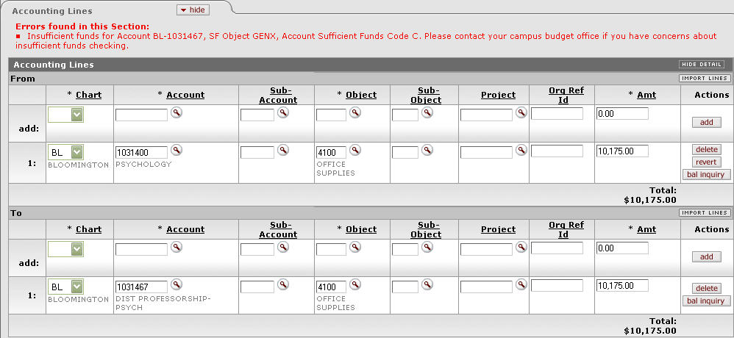
Figure 3-1 An error message is displayed in the Accounting Lines tab.
A message is displayed in the Accounting Lines tab indicating which account does not have sufficient funds.
Not all KFS financial document types perform sufficient funds checking. The following document types do not check for sufficient funds:
Advance Deposit
Auxiliary Voucher
Cash Management Document
Cash Receipt
Credit Card Receipts
Journal Voucher
Pre-Encumbrance
Procurement Card

Flexible Offset
The KFS uses the Offset Generation table to generate the appropriate offsets for transactions. This table indicates the Object Code used in offset generation, based on the transaction’s Chart, Fiscal Year, Document Type and the Balance Type it impacts. Offsets are generated automatically by a KFS e-doc or in the Scrubber during General Ledger processing.
Normally offsets are applied to the same account as the transaction that generated the offset. But the KFS has a Flexible Offset feature that allows institutions to have offset entries applied to different accounts.
This KFS feature includes two functions that are discussed in detail below:
- Flexible Banking Offset
- Flexible Offsets by Account

Flexible Banking Offsets
Document types that require a user to specify a bank account number (such as the Advance Deposit or Credit Card Receipt documents), can apply offset entries to a special account associated with that bank account number. If the Flexible Banking Offset option is enabled within the Financial Systems Parameter, an additional set of cash entries are created to a designated accounting string (Chart, Account, Sub-Account, Object Code, Sub-Object Code) defined in the Bank Account Maintenance Document. These entries occur in addition to the normally generated cash offsets created to balance a set of transactions and, in effect, reclassify the generic cash entry to a bank specific cash entry for reconciliation and tracking purposes. If the Flexible Banking Offset parameter is not selected, the normal balancing cash entries are created but the reclassification of cash to a bank specific entry is not performed.
For more information about the Bank Account Maintenance Document, see “Error: Reference source not found” in Chapter 4, page Error: Reference source not found.

Flexible Offsets by Account
This option allows the KFS to redirect offset entries for an account to another specified account. This allows the KFS to accommodate tracking offsets such as cash or liabilities in central designated accounts, as opposed to tracking such offset entries in every account. The Offset Account Maintenance Document defines what the offset account should be for an Object Code and Account Number combination.
If the Offsets by Account option are enabled within the Financial Systems Parameter, the KFS goes through a special process in e-docs and in the Scrubber during General Ledger processing, to determine the account that the offsets should be made to for a given transaction.
For information about the Offset Account Maintenance Document, see “Error: Reference source not found” in Chapter 4, page Error: Reference source not found.

Flexible Offsets Financial System Parameters
The Flexible Banking Offsets and Flexible Offsets by Account parameters are called FLEXIBLE_CLAIM_ON_CASH_BANK_ENABLED_FLAG and FLEXIBLE_OFFSET_ENABLED_FLAG respectively. They can be found using the Financial System Parameter lookup from the Nervous System menu group within the Administration tab.
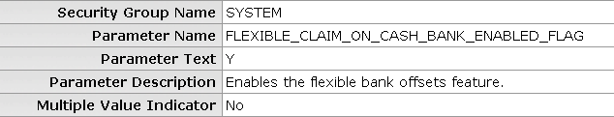
Figure 3-2 Flexible Banking Offsets Parameter
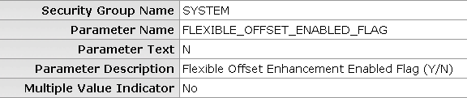
Figure 3-3 Flexible Offsets by Account Parameter
For information about the Financial System Parameter administration document, see “Error: Reference source not found” in Chapter 4, page Error: Reference source not found.
Generation of offsets on e-docs when the flexible offsets function is enabled occurs as follows:
  - The offset object code is defined in the Offset Definition table.
  - The object code and account number are searched from the Offset Account table.
  - If a match is found in the Offset Account table, the offset is made in the offset account defined there.
  - If no match is found, the offset is made in the same account on which the original transaction occurred.
Generation of offsets in the Scrubber when the flexible offsets function is enabled occurs as follows:
  - The Scrubber looks up the document type for a transaction in the Document Type table.
  - If the ‘Transaction Scrubber Offset Generation’ option of the document type is not selected, the scrubber does not generate offsets. This prevents the Scrubber from attempting to balance transactions where the KFS has already applied offsets to other accounts as part of the e-doc offset generation process.
  - If the ‘Transaction Scrubber Offset Generation’ option of the document type is selected, the Scrubber determines the transaction’s offset Object Code using the Offset Definition table.
  - The Object Code and Account Number are searched from the Offset Account table.
  - If a match is found in the Offset Account table, the offset is made in the Offset Account defined there.
  - If no match is found, the offset is made in the same account on which the original transaction occurred.

General Ledger Correction Process (GLCP)
The General Ledger Correction Process (GLCP) document is used by central administration to correct errors that occur during General Ledger processing. The GLCP document allows users to correct errors in several ways.

GLCP Document Layout
The GLCP document includes the Summary, Correction Process; Documents in System; Correction File Upload, Search Results; Edit Options and Action; Edit Criteria; and Search Criteria for Manual Edit tabs. The method chosen for correction determines which tabs on the document are active and which are inactive.
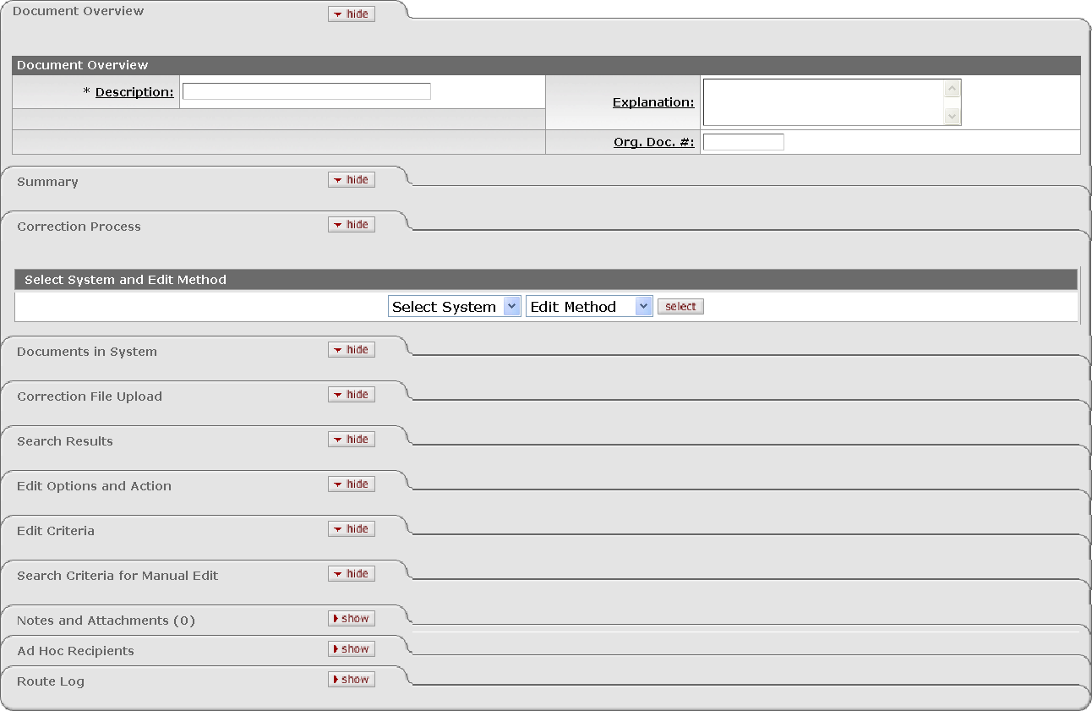
Selection of the method in the Correction Process tab determines which tabs to complete
Figure 3-4 General Ledger Correction Process Document
The GLCP document allows users to correct errors in several ways. The method chosen for correction determine which tabs on the document are active and which are inactive. The possible correction methods are as follows:

- Database/Using Criteria Corrections: This method allows you to select and make corrections to a file from the Origin Entry Group table. Changes are made by specifying search criteria to identify rows of data you wish to alter and what changes you wish to make to those rows. Use this option when your corrections include consistent patterns (for example, changing Fiscal Year for a certain group of transactions at once).
- Database/Manual Edit Corrections: This method allows you to select and make corrections to a file from the Origin Entry Group table. In this case, rather than being automated by specified criteria, changes are made manually to the file's data by the GLCP initiator. Use this option when your corrections include random patterns (for example, changing Fiscal Year on one transaction but changing Object Code on another and so on).
- File Upload/Using Criteria Corrections: This method allows you to upload an existing file from an external source and specify search criteria to identify rows of data you wish to alter and what changes you wish to make to those rows. Use this option when you have a file from an external source to upload to KFS, and wish to make changes in the KFS before submitting the document.
- File Upload/Manual Edit Corrections: This method allows you to upload an existing file from an external source and manually make corrections to that file before adding it for processing. Use this option if you would rather work on the corrections on your computer and upload the file; if necessary you can manually make changes in the KFS before submitting the document.

The following chart summarizes which tabs are active for the selected correction process.
Table 3-1 Correction process and active tabs
Process | Doc in System | Correction File Upload | Search Results | Edit Options and Action | Edit Criteria | Search Criteria for Manual Edit | Summary
Database/Using Criteria |  |  |  |  |  |  | 
Database/Manual Edit |  |  |  |  |  |  | 
File Upload/Using Criteria |  |  |  |  |  |  | 
File Upload/Manual Edit |  |  |  |  |  |  | 

Correction Process Tab
The Correction Process tab is used to select the system (Database or File Upload) and the edit method (Using Criteria or Manual Edit) that should be used for corrections. Once a selection is made, click select. This opens up available options on the other tabs of the document. The possible combinations and document tabs available to those combinations are discussed in Initiating a GLCP document discussion.
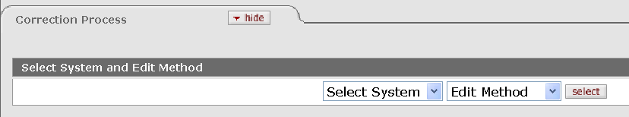
Figure 3-5 Correction Process Tab

Documents in System Tab
The Documents in the System tab displays the files available for editing. The Documents in System list is populated when you click select in the Correction Process tab.
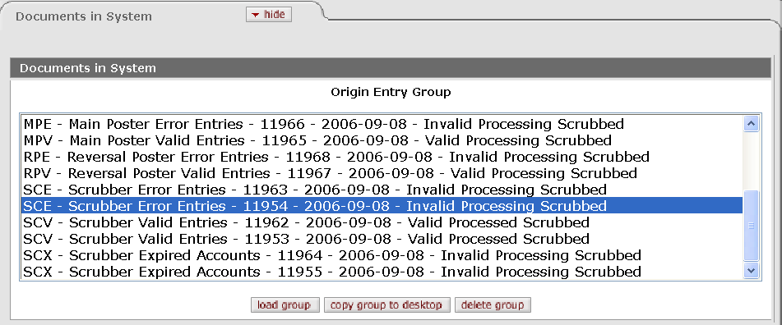
Figure 3-6 Database/Using Criteria Corrections
This list contains files that are in the Origin Entry Group table. These files are created by the accounting cycle at the various steps of General Ledger Processing, such as the running of the Scrubber, the generation of Indirect Cost Recovery entries, or the generation and posting of Reversals.
Entries in this table contain an abbreviation indicating the type of file, followed by a descriptive name of that file. The prefix of each line indicates where in the General Ledger process the file originated.

Table 3-2 prefix and File Origination
Prefix | Description
BACK | Backup transactions from previous General Ledger Processing Cycles
EDOC | Transactions generated by KFS e-docs
GLCP | Transactions created through use of the General Ledger Correction Process document
ICR | Transactions generated by the Indirect Cost Recovery generation process
ICRE | Error transactions created by the Indirect Cost Recovery generation process
ICRV | Valid transactions from the Indirect Cost Recovery posting process
MPE | Error transactions from the Main General Ledger posting process
MPV | Valid transactions from the Main General Ledger posting process
RPE | Error transactions from the Reversal posting process
RPV | Valid transactions from the Reversal posting process
SCE | Error transactions dropped from the Scrubber
SCV | Valid transactions processed through the Scrubber
SCX | Transactions with expired accounts identified by the Scrubber

Each entry in the table is also assigned a unique origin entry group ID followed by the date the file was generated. The final three entries on each line include important information about the current state of processing for this group of entries:

Valid/Error: Indicates whether this group of transactions contains valid data or error transactions. In the case of a newly created input file, this value specifies whether the set of transactions is valid and thus may be eligible for processing.
Process/Don’t Process: Indicates whether this group of transactions will be processed or has been processed by the accounting cycle.
Scrub/Don’t Scrub: Indicates if this group of transactions should be input into the Scrubber. Some origin entry groups are needed by other parts of the accounting cycle and may be marked as Don’t Scrub.
Click the file you wish to correct to select it and use the action buttons at the bottom of the tab to take an action on that file. The options available are loading a group, copying a group to desktop, and deleting the group.
Figure 3-7 Documents in System Tab Action Buttons

Loading a Group
Clicking load group displays the selected file on the Search Results tab and makes it available for editing using the fields on the Edit Criteria tab.
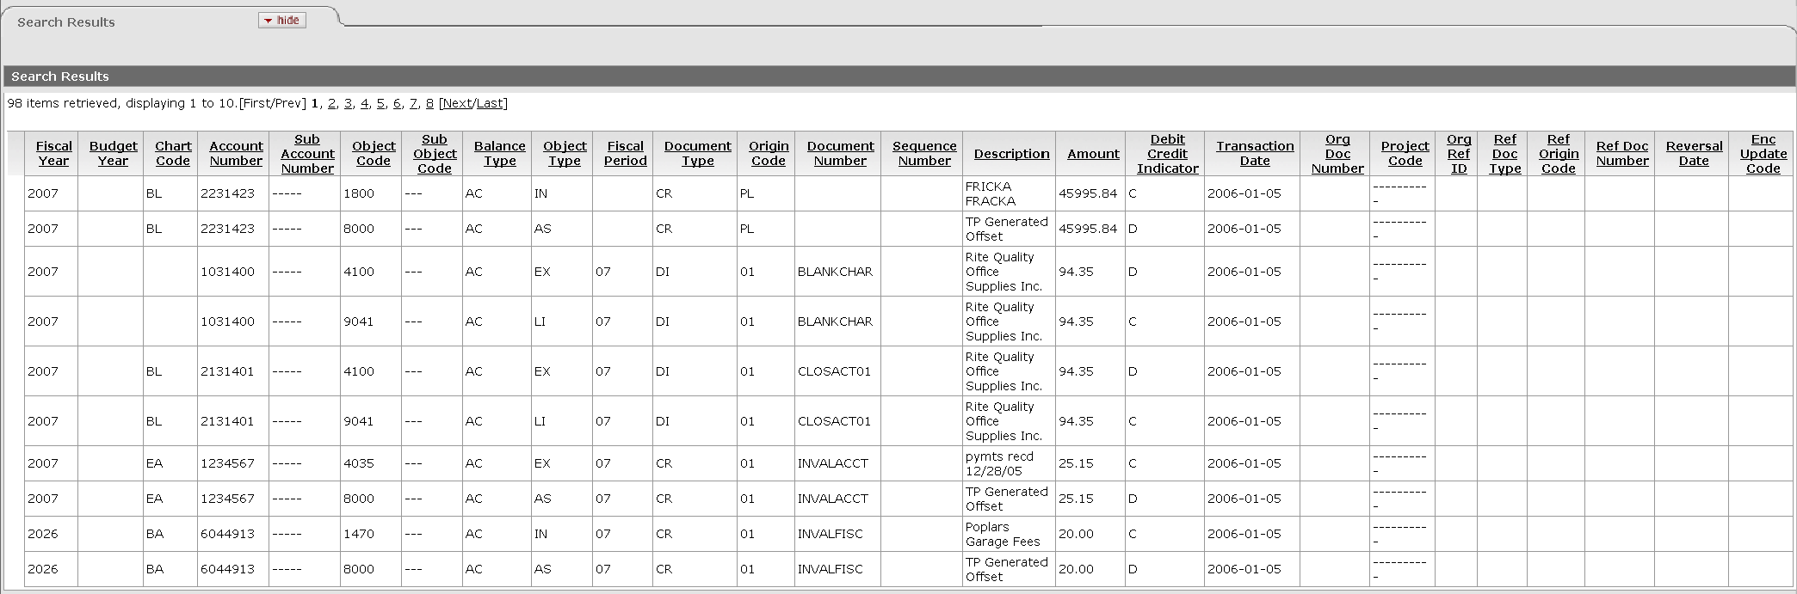
Figure 3-8 Loaded Document in the Search Result Tab

Edit Option
When you select File Upload/Manual Edit Correction method, the system displays edit below the loaded data.
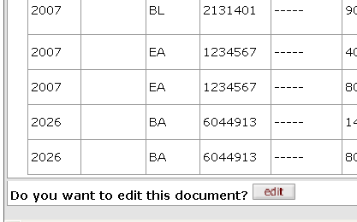
Figure 3-9 Edit Option in the Search Result Tab
Clicking edit changes the tab into a manual edit. Click edit corresponding to the row that you wish to edit and make changes in the manual edit section with editable boxes below the loaded rows.

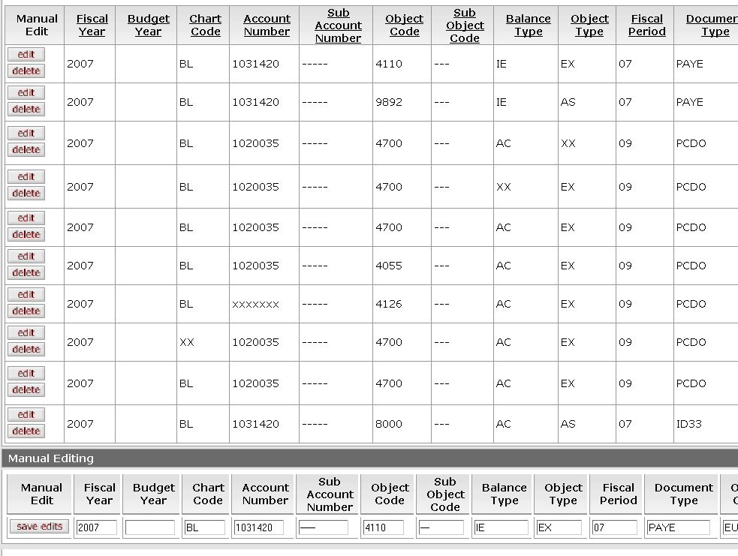
Click the edit button. The corresponding row becomes available for editing in the Manual Editing section.
Figure 3-10 The loaded rows become available for editing.
Click save edits when you are done editing the row. The changes you made are immediately reflected in the loaded row.

Copying the Group to Desktop
This option allows you to open or save a copy of this file locally. When you click copy group to desktop, the File Download dialog window opens, prompting you to either open, save or cancel.
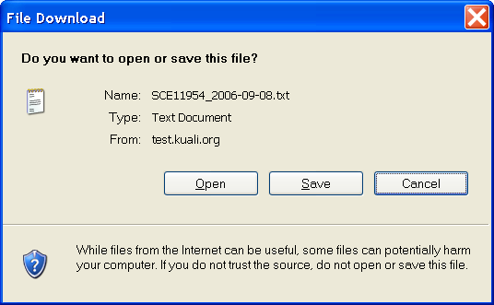
Figure 3-11 Copying the group to desktop
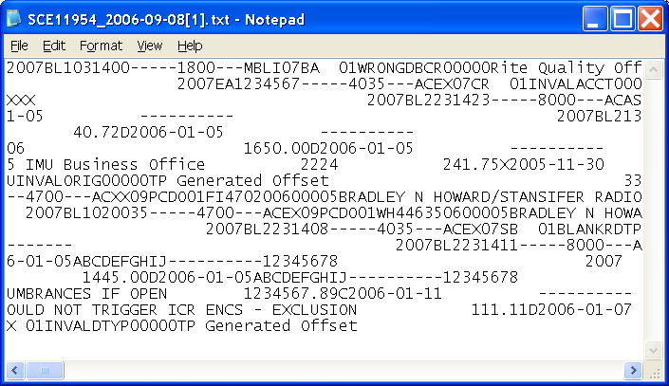
Figure 3-12 Content of the loaded file

Remove Group from Processing
This option pulls the file from the accounting cycle, excluding it from future processing.

Correction File Upload Tab
The Correction File Upload tab allows you to locate and load the file you wish to use. This tab is activated when Upload/Manual Edit or Upload/Using Criteria is selected.
Click Browse.
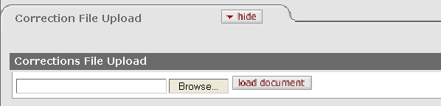
Figure 3-13 Correction File Upload Tab
Navigate to the file through the choose file dialog select the file and click Open.
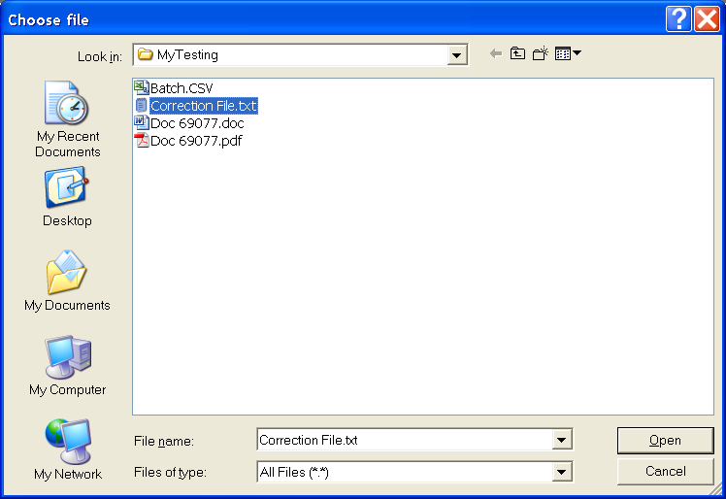
Figure 3-14 The choose file Dialog Window
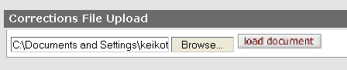
Figure 3-15 The selected file path appears in the Corrections File Upload section.
Click load document and the content of the correction file you have selected appears in the Search Results tab.
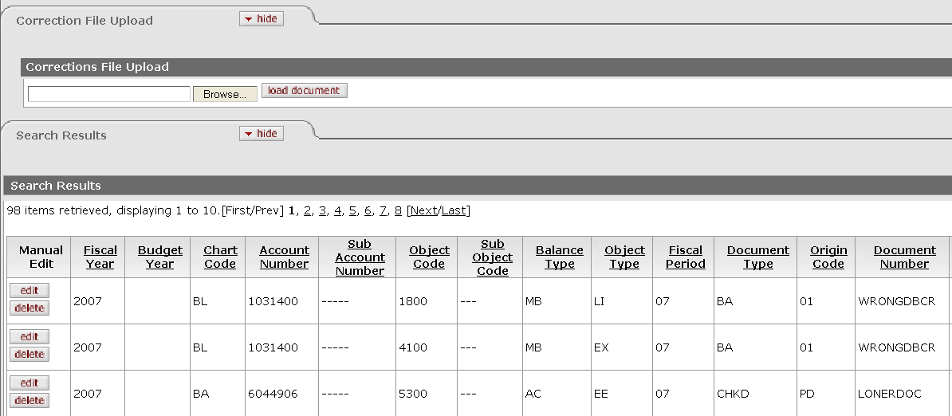
Figure 3-16 The data is loaded from the uploaded file in the Search Results tab.

Edit Options and Actions Tab
The Edit Options and Actions tab give you options for the type of correction file you wish to generate.
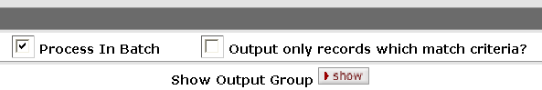
Figure 3-17 Edit Options and Action Tab
Table 3-3 Edit Options and Actions Tab Definition
Title | Description
Process In Batch | Optional. Select the check box if you want the system to generate correction entries defined as Valid Process Scrub, meaning they need to be passed through the regular General Ledger processing cycle. Clear the check box if you want to the system to generate correction entries defined as Valid Don’t Process Scrub, which will not be passed through the regular General Ledger processing cycle.
Output only records which match criteria? | Optional. Select the check box if you want to generate a group that contains only the records that are changed by the search and modification criteria. Clear the check box if you want to generate a group containing both the records that match the search and modification criteria as well as those that don’t match.
Show Output Group | This button acts as a switch and lets the user view either the output group after the changes on the GLCP e-doc have been applied or view the original input group prior to any changes. The results are displayed in the Search Results tab.

Edit Criteria Tab
The Edit Criteria tab is where you identify the rows of data you wish to make changes to and specify what those changes should be. To make corrections you can create one or more groups of Search Criteria and corresponding Modification Criteria. Each group can have multiple Search and Modification Criteria. The Edit Criteria tab has the Search Criteria section and the Modification section.

Search Criteria Section
To add Search Criteria, begin by selecting a Field you wish the KFS to search on. Then choose an Operator (such as Equals or Greater Than) and a Value indicating how the KFS should identify rows in relation to the Field you have selected. Click add to enter your Search Criteria into a group. For example, you might wish to find and make corrections to all rows in the selected file that contain Account Number 1031400 and a transaction date of September 1, 2006. You would make the following entries in the Search Criteria fields:
Field | Operator | Value
Account Number | Equals | 1031400
Transaction Date | Equals | 09/01/2006

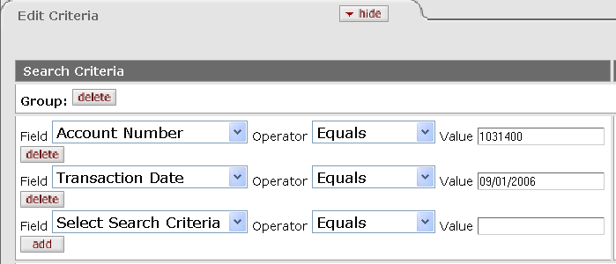
Figure 3-18 Edit Criteria Tab

This would effectively find all transactions in that file that involve account 1031400 and have a transaction equal to 09/01/2006. From there you could change the account number on those transactions to 1031420.
You must click add to add the Search Criteria.

Adding a Group
You can make multiple changes to a file based on different Search Criteria by adding additional groups. To add another group, click add by 'Add Groups.' This creates another entry in this tab where you can enter different Search and Modification Criteria.
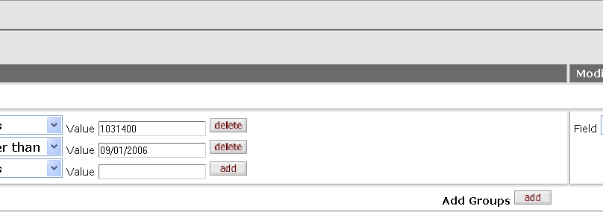
Figure 3-19 Adding Groups
For example, if you wish to add another criterion which selects the transactions with the Project Code of 'ABC,' you may specify it in the second group by selecting the Project Code field and setting the value to 'ABC.' To specify the correction to change the value 'ABC' to 'XXX,' select 'Project Code' from the Field list in the Modification Criteria section and enter the value of 'XXX.'

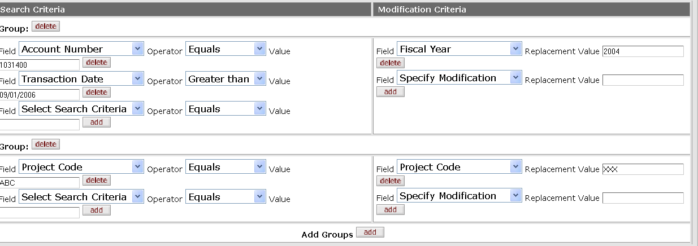
Additional group is added
Figure 3-20 Adding additional groups

Modification Criteria Section
The Modification Criteria section is where you specify how you want the corrections to be made.
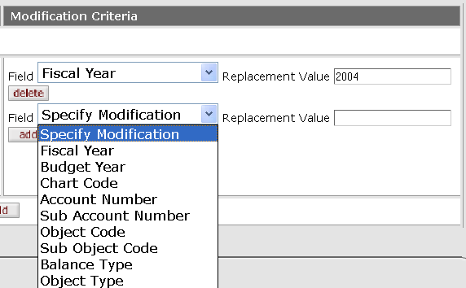
Figure 3-21 Modification Criteria Section
Table 3-4 Modification Criteria section definition
Title | Description
Field | Optional. Select the field that you wish to make the correction from the Field list.
Replacement Value | Optional. Enter the value to be replaced.

You must click add to add the modification criteria.

Search Criteria for Manual Edit Tab
When manually editing a file you can use the Search Criteria for Manual Edit tab to apply a filter to the rows of data and only display the rows that match your search criteria. This can be helpful when working with a large file that only needs corrections to a limited number of rows. To filter the rows displayed in the Search Results tab, complete the criteria as described for the Search Criteria tab when using the Database/Using Criteria correction method.
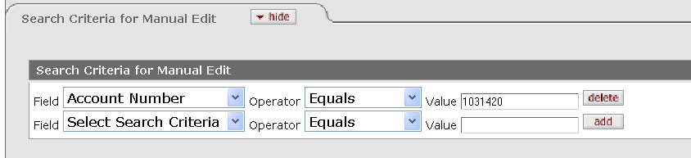
Figure 3-22 Search Criteria for Manual Edit Tab
For information about how to add a search criteria, see "Search Criteria Section" earlier in this chapter, page 34.
Click search when you are done adding the search criteria.
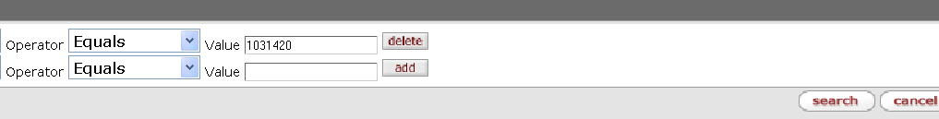
Figure 3-23 Click search.

Submitting a Document
When you complete the required tabs, click submit. The message is displayed in the upper left corner.
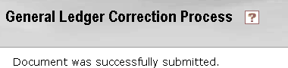
Figure 3-24 Successfully submitted message

Summary Tab
The Summary tab is automatically completed after the GLCP document is submitted. It contains summary information about the debits and credits impacted and the number of rows of data that the GLCP document output.
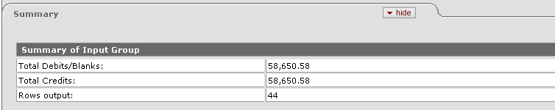
Figure 3-25 Summary Tab

Business Rules
The GLCP Maintenance Document is only available to members of the KUALI_ROLE_GENERAL_LEDGER_CORRECTION_PROCESS_DOCUMENT_USER workgroup.

Process Overview
The document routes to the KUALI_FMSOPS workgroup for approval. The document status becomes FINAL when the document is approved and the transaction is posted to the General Ledger during the next G/L batch process.
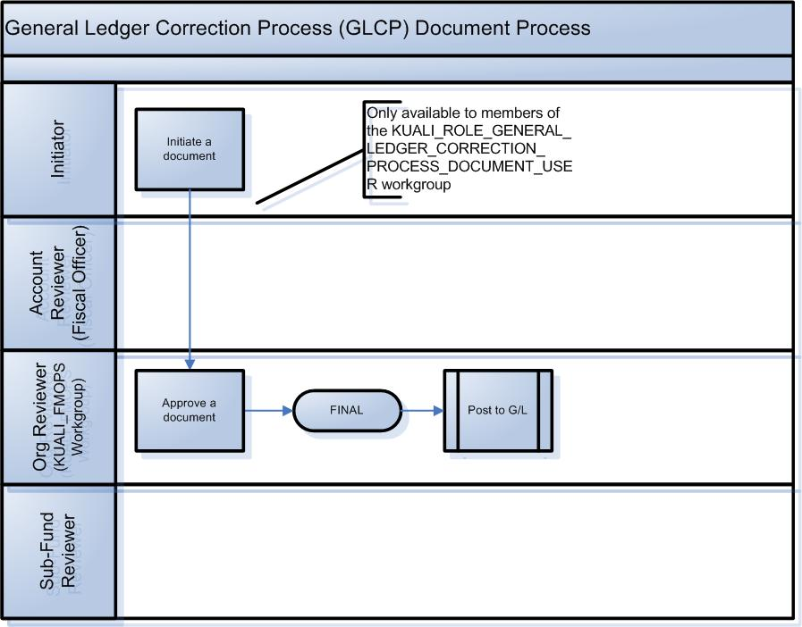
Figure 3-26 GLCP Document Workflow

Initiating a GLCP Document
The following covers four different methods to make corrections to General Ledger.

Database/Using Criteria Correction Method
  - Select Database and Using Criteria and click select in the Correction Process tab.
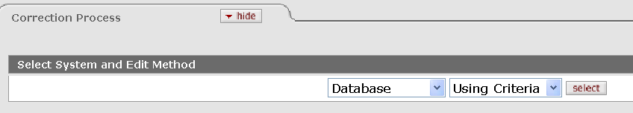
Figure 3-27 Database/Using Criteria Method
The available files for editing appear in the Origin Entry Group list in the Documents in System tab.
  - Select the file in the Documents in System list and click load group.
  - Enter your Search and Modification Criteria in the Edit Criteria tab.
Click add as you add the search or modification criteria.
  - Select the type of correction file to be created in the Edit Options and Action tab.
  - Click submit to process your GLCP document.
A new file to be added to the General Ledger processing cycle is created.
  - Observe the message 'Document was successfully submitted.'
  - Review the Correction Result tab.
  - Review the Route Log tab.
The document is routed to the KUALI_FMPOS Workgroup
For more information about the Route Log, see “Error: Reference source not found" in Chapter 7, page Error: Reference source not found.
  - Appropriate Org Reviewers (KUALI_FMOPS Workgroup) approve the document.
For actual steps to approve a document, refer to “Error: Reference source not found” in Chapter 7, page Error: Reference source not found.

Database/Manual Edit Corrections Method
  - Select Database and Manual Edit and click select in the Correction Process tab.
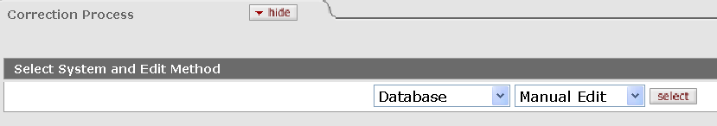
Figure 3-28 Database/Manual Edit Method
The available files for editing appear in the Origin Entry Group list in the Documents in System tab.
  - Select the file in the Documents in System list and click load group.
  - Click edit.
  - Enter search criteria in the Search Criteria for Manual Edit tab to filter the data (optional). Click Search.
  - Make manual changes to the loaded row.
Click save edits when you are done with each row.
  - Select the type of correction file to be created in the Edit Options and Action tab.
  - Click submit.
A new file to be added to the General Ledger processing cycle is created.
  - Observe the message 'Document was successfully submitted.'
  - Review the Correction Result tab
  - Review the Route Log tab.
The document is routed to the KUALI_FMPOS Workgroup
For more information about the Route Log, see “Error: Reference source not found" in Chapter 7, page Error: Reference source not found.
  - Appropriate Org Reviewers (KUALI_FMOPS Workgroup) approve the document.
For actual steps to approve a document, refer to “Error: Reference source not found” in Chapter 7, page Error: Reference source not found.

File Upload/Using Criteria Corrections
  - Select File Upload and Using Criteria; and click selection in the Correction Process tab.
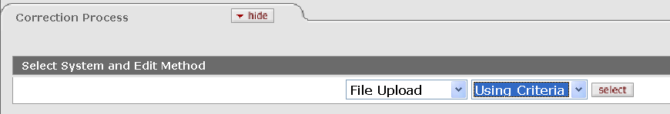
Figure 3-29 File Upload/Using Criteria Method
  - Browse and load the file in the Correction File Upload tab.
  - Enter your Search and Modification Criteria in the Edit Criteria tab.
Click Add as you add the search or modification criteria.
  - Select the type of correction file to be created in the Edit Option and Action tab.
  - Click submit to process your GLCP document.
A new file to be added to the General Ledger processing cycle is created.
  - Observe the message 'Document was successfully submitted.'
  - Review the Correction Result tab.
  - Review the Route Log tab.
The document is routed to the KUALI_FMPOS Workgroup.
For more information about the Route Log, see “Error: Reference source not found" in Chapter 7, page Error: Reference source not found.
  - Appropriate Org Reviewers (KUALI_FMOPS Workgroup) approve the document.
For actual steps to approve a document, refer to “Error: Reference source not found” in Chapter 7, page Error: Reference source not found.

File Upload/Manual Edit Corrections
  - Select File Upload and Manual Edit; and click select in the Correction Process tab.
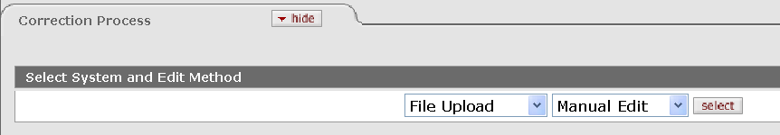
Figure 3-30 File Upload/Manual Edit Method
  - Browse and load the file in the Correction File Upload tab.
  - Enter search criteria in the Search Criteria for Manual Edit tab to filter the data (optional). Click Search.
  - Make manual changes to the loaded row.
Click save edits when you are done with each row.
  - Select the type of correction file to be created in the Edit Options and Action tab.
  - Click submit.
A new file to be added to the General Ledger processing cycle is created.
  - Observe the message 'Document was successfully submitted.'
  - Review the Correction Result tab.
  - Review the Route Log tab.
The document is routed to the KUALI_FMPOS Workgroup
For more information about the Route Log, see “Error: Reference source not found" in Chapter 7, page Error: Reference source not found.
  - Appropriate Org Reviewers (KUALI_FMOPS Workgroup) approve the document.
For actual steps to approve a document, refer to “Error: Reference source not found” in Chapter 7, page Error: Reference source not found.

Summary
In this chapter, you were introduced to the different General Ledger processes that the KFS supports. You learned about the Scrubber validation and offset generation process and how they generate entries for Capitalization, Plant Indebtedness, Cost Share and Indirect Cost Recovery. You also learned how the Sufficient Funds option can be used to limit the application of expenses to accounts and how the Flexible Offsets options can be used to apply generated offsets to specified accounts. You were also introduced to the basic navigation and operations of the General Ledger Correction Process document, including the menus, screen layout, common navigations, business rules, workflow, how to create or edit a document, and how to route a document.

